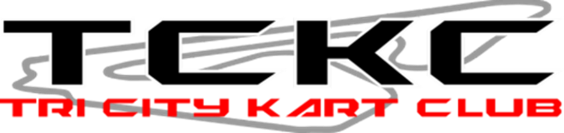

**2024 Rules and Regulations Addendum**

**CLUB RULES**

16a. No consumption of alcohol on property when track is hot (practice and races). TCKC is a drug free zone, no illicit drugs are allowed on the property. Offenders are subject to disciple up to and including suspension.

**EQUIPMENT RULES**

4a. Rain tires are allowed at the discretion of the driver, in all classes.

7a. Honda GX50 Only, motor must remain stock, no modifications allowed.